Practical 5
Part A
1) | AIM1. Shape areas: an abstract Shape with abstract area(); subclasses Circle, Rectangle, Triangle. Put a mix in a Shape[] and loop once to print each area and the running total,
Code | import java.util.*;  abstract class Shape{  public abstract float area();  }  class Circle extends Shape{  public float radius;  public Circle(int r){  radius=r;  }  public float area(){  return 3.14f*radius*radius;  }  }  class Rectangle extends Shape{  public float lenght;  public float breadth;  public Rectangle(float l, float b){  lenght = l;  breadth = b;  }  public float area(){  return lenght * breadth;  }  }  class Triangle extends Shape{  public float base;  public float height;  public Triangle(float b, float h){  base= b;  height = h;  }  public float area(){  return 0.5f*base*height;  }  }  public class Main {  public static void main(String[] args) {  Shape[] shapes = {new Circle(5),new Rectangle(4, 6),new Triangle(3, 8),new Circle(3)};  double total_area = 0;  double largest_area = 0;  for (Shape shape : shapes) {  double current_area = shape.area();  System.out.printf("Area: %.2f%n", current_area);  total_area += current_area;  if (current_area > largest_area) {  largest_area = current_area;  }  }  System.out.printf("%nTotal Area: %.2f%n", total_area);  System.out.printf("Largest Area: %.2f%n", largest_area);  }  }
Output | 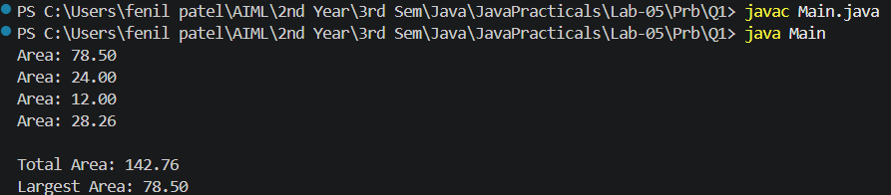
2) | AIM: Payroll: an abstract Employee with abstract monthlySalary(); FullTime (fixed), PartTime (hours × rate) and Intern (stipend), each calling super for the shared name/id. Loop a mixed array to print each salary and the total; use instanceof to add a note only for interns.
Code | import java.util.*;  abstract class Employee {  public String employee_name;  public int employee_id;  public Employee(String name, int id) {  employee_name = name;  employee_id = id;  }  public abstract float monthlySalary();  }  class FullTime extends Employee {  public float salary;  public FullTime(String name, int id) {  super(name, id);  salary = 100000;  }  public float monthlySalary() {  return salary;  }  }  class PartTime extends Employee {  public int hour;  public float rate;  public PartTime(String name, int id, int h, float r) {  super(name, id);  hour = h;  rate = r;  }  public float monthlySalary() {  return rate * hour;  }  }  class Intern extends Employee {  public float salary;  public Intern(String name, int id) {  super(name, id);  salary = 10000;  }  public float monthlySalary() {  return salary;  }  }  public class Main {  public static void main(String[] args) {  Employee[] employees = {  new FullTime("Ansh", 101),  new PartTime("Raj", 102, 80, 300),  new Intern("Jay", 103),  new FullTime("Karan", 104),  new Intern("Dev", 105)  };  float total_salary = 0;  for (Employee employee : employees) {  float salary = employee.monthlySalary();  System.out.println("Employee ID: " + employee.employee_id +", Name:" + employee.employee_name +", Salary: " + salary);  if (employee instanceof Intern) {  System.out.println("Employee is an Intern.");  }  total_salary = total_salary +salary;  }  System.out.println("Total Monthly Payroll:" + total_salary);  }  }
Output | 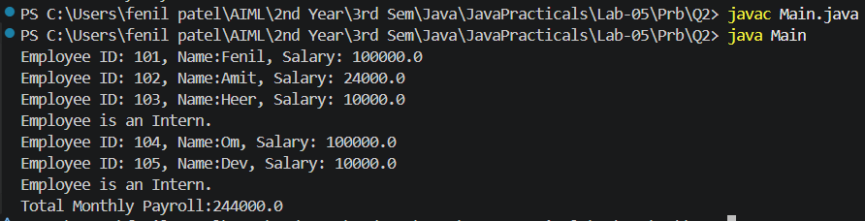
Q3) | AIM: Model a few media types that each compute a late fee differently and total the fees for a returned batch. Design the hierarchy and rules yourself
Code | abstract class Media {  public String media_name;  public int media_id;  public int late_days;  public Media(String n, int i, int d) {  media_name = n;  media_id = i;  late_days = d;  }  public abstract float late_fee();  }  class Book extends Media {  public Book(String name, int id, int days) {  super(name, id, days);  }  public float late_fee() {  return late_days * 2;  }  }  class DVD extends Media {  public DVD(String name, int id, int days) {  super(name, id, days);  }  public float late_fee() {  return late_days * 5;  }  }  class Game extends Media {  public Game(String name, int id, int days) {  super(name, id, days);  }  public float late_fee() {  return late_days*8;  }  }  public class Main {  public static void main(String[] args) {  Media[] returned_media = {new Book("Java Programming", 101, 3),new DVD("Avengers", 102, 2),new Game("Minecraft", 103, 5),  new Book("Data Structures", 104, 4),new DVD("Interstellar", 105, 1)};  float total_fee=0;  for (Media media:returned_media) {  float fee = media.late_fee();  System.out.println("Media ID:" + media.media_id +",Name:" + media.media_name +",Late Days:" + media.late_days +",Late Fee:Rs." + fee);  total_fee = total_fee + fee;  }  System.out.println("Total Late Fees:Rs." + total_fee);  }  }
Output | 